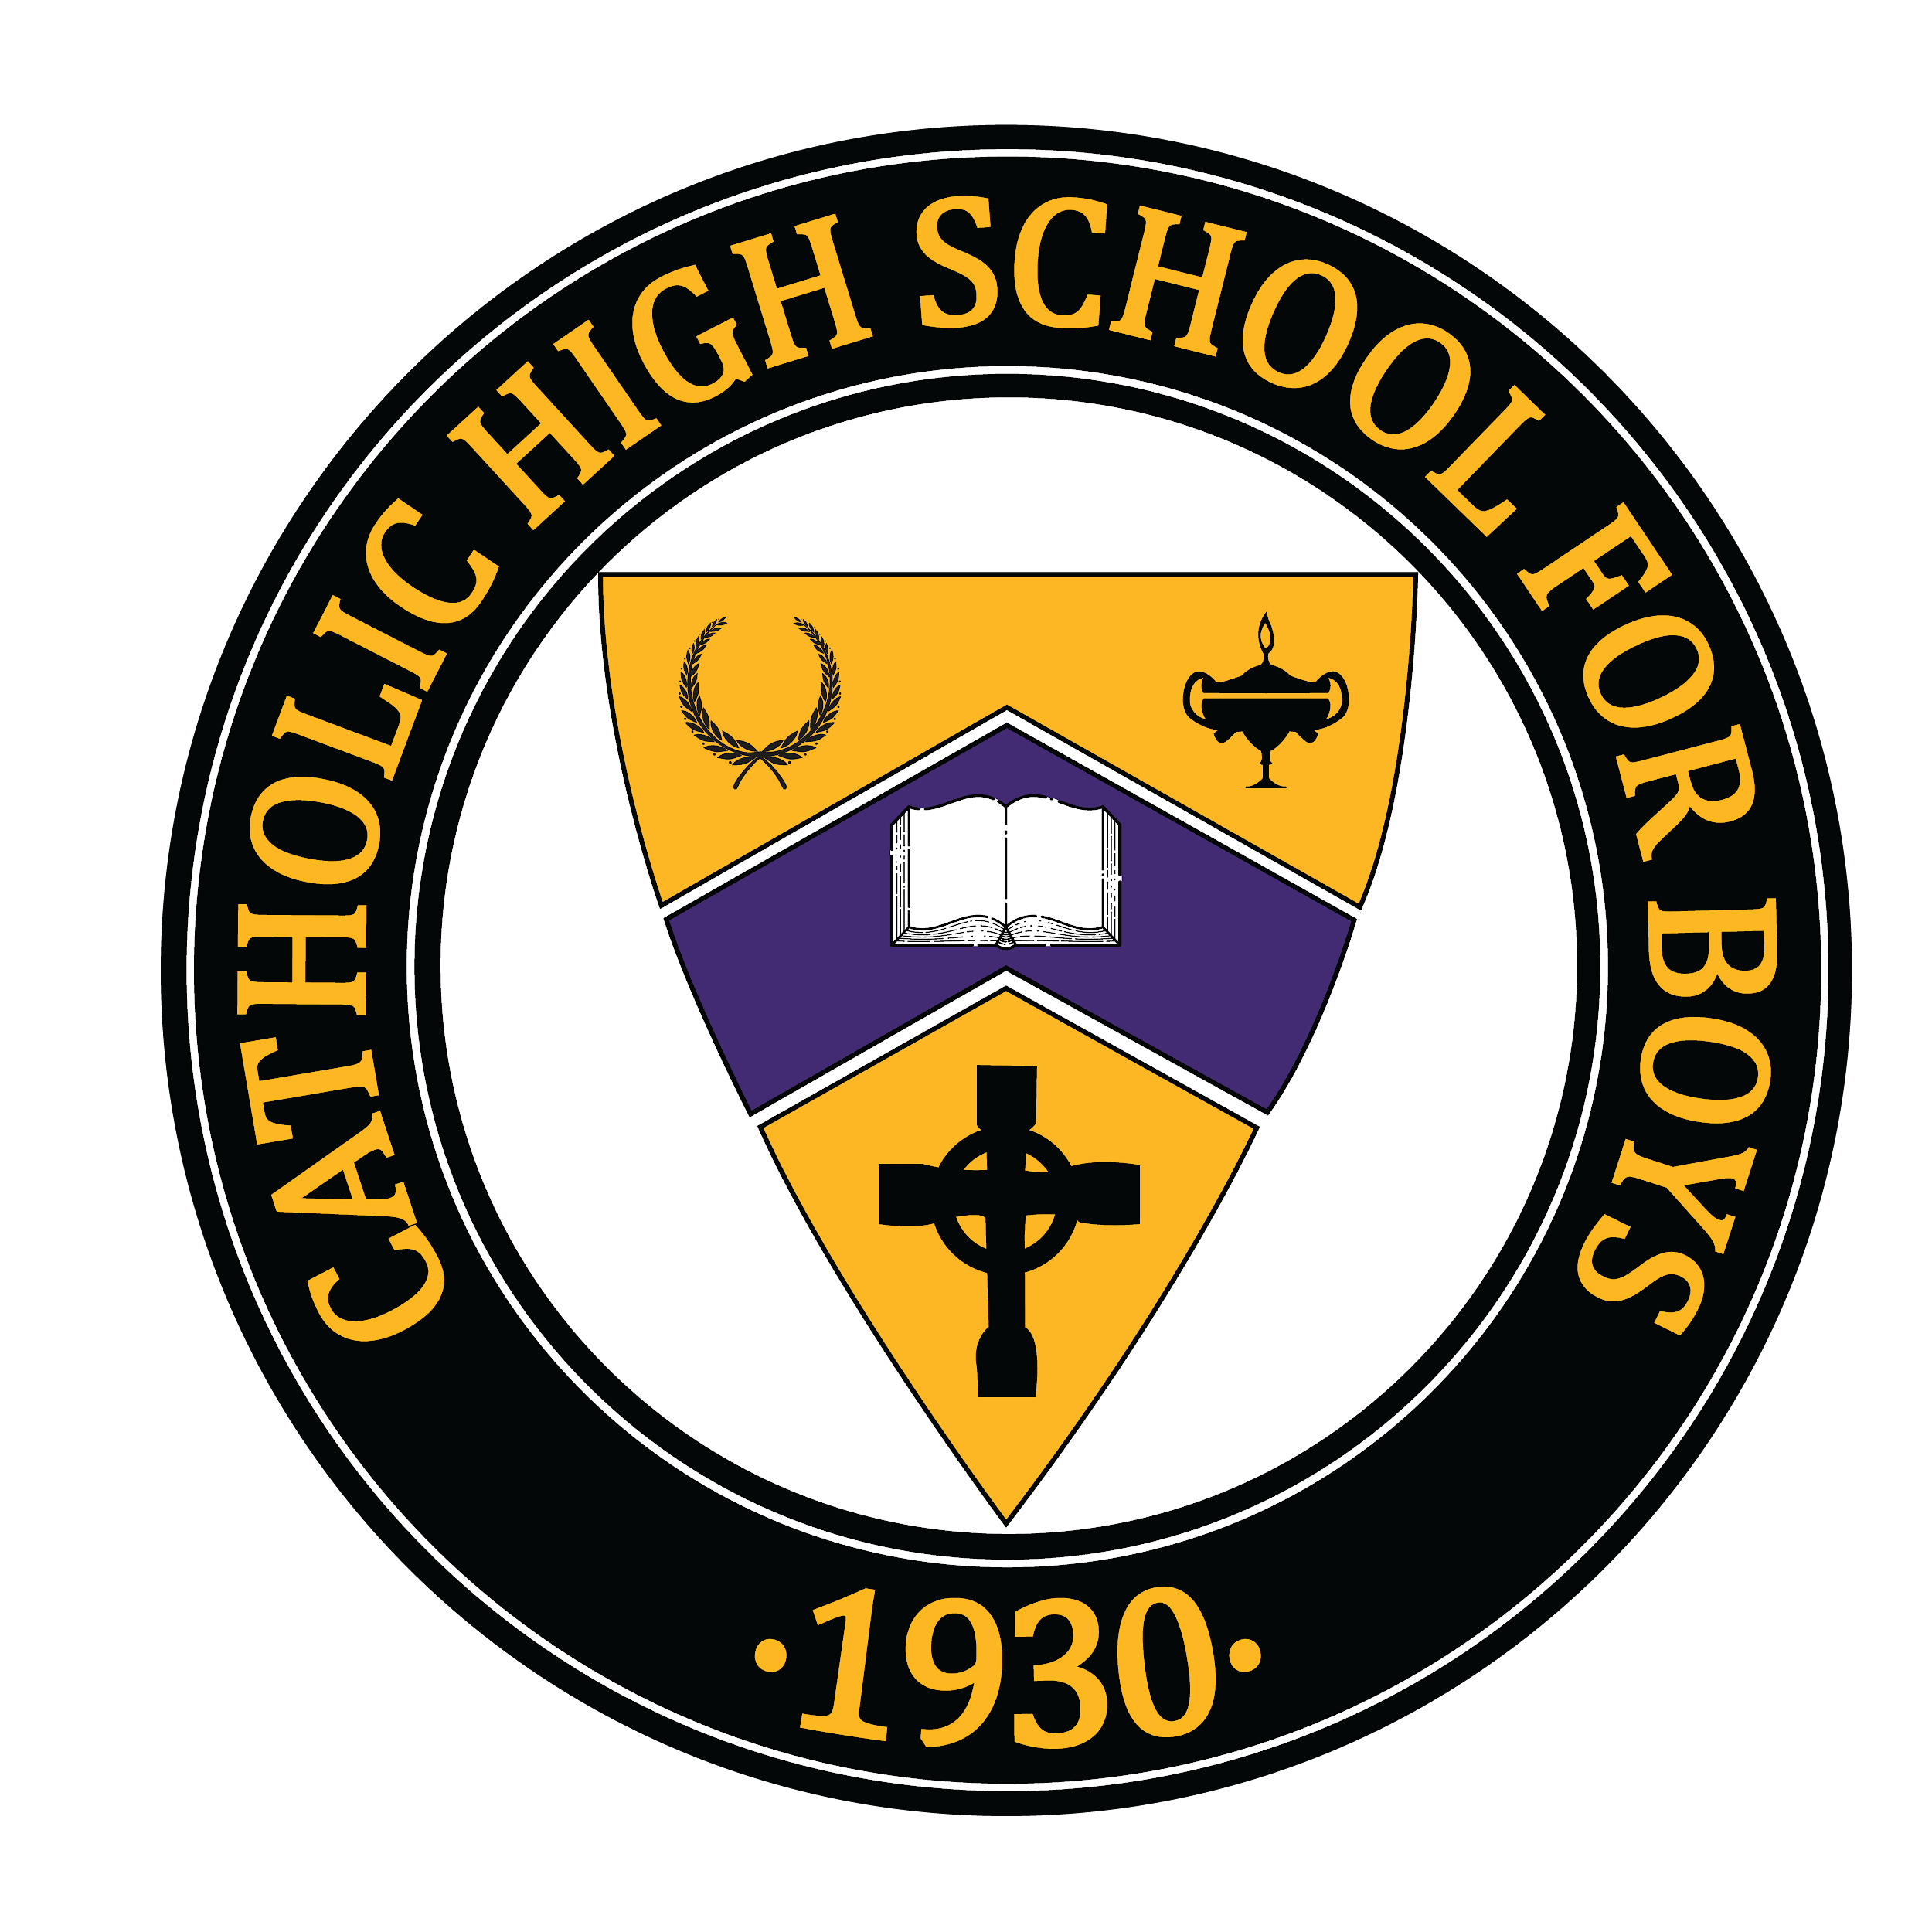
For more information, contact:
Shealyn Sowers
shealyn@ghidotti.com
501-607-0965

Three Catholic High School Seniors Named National Merit Semifinalists

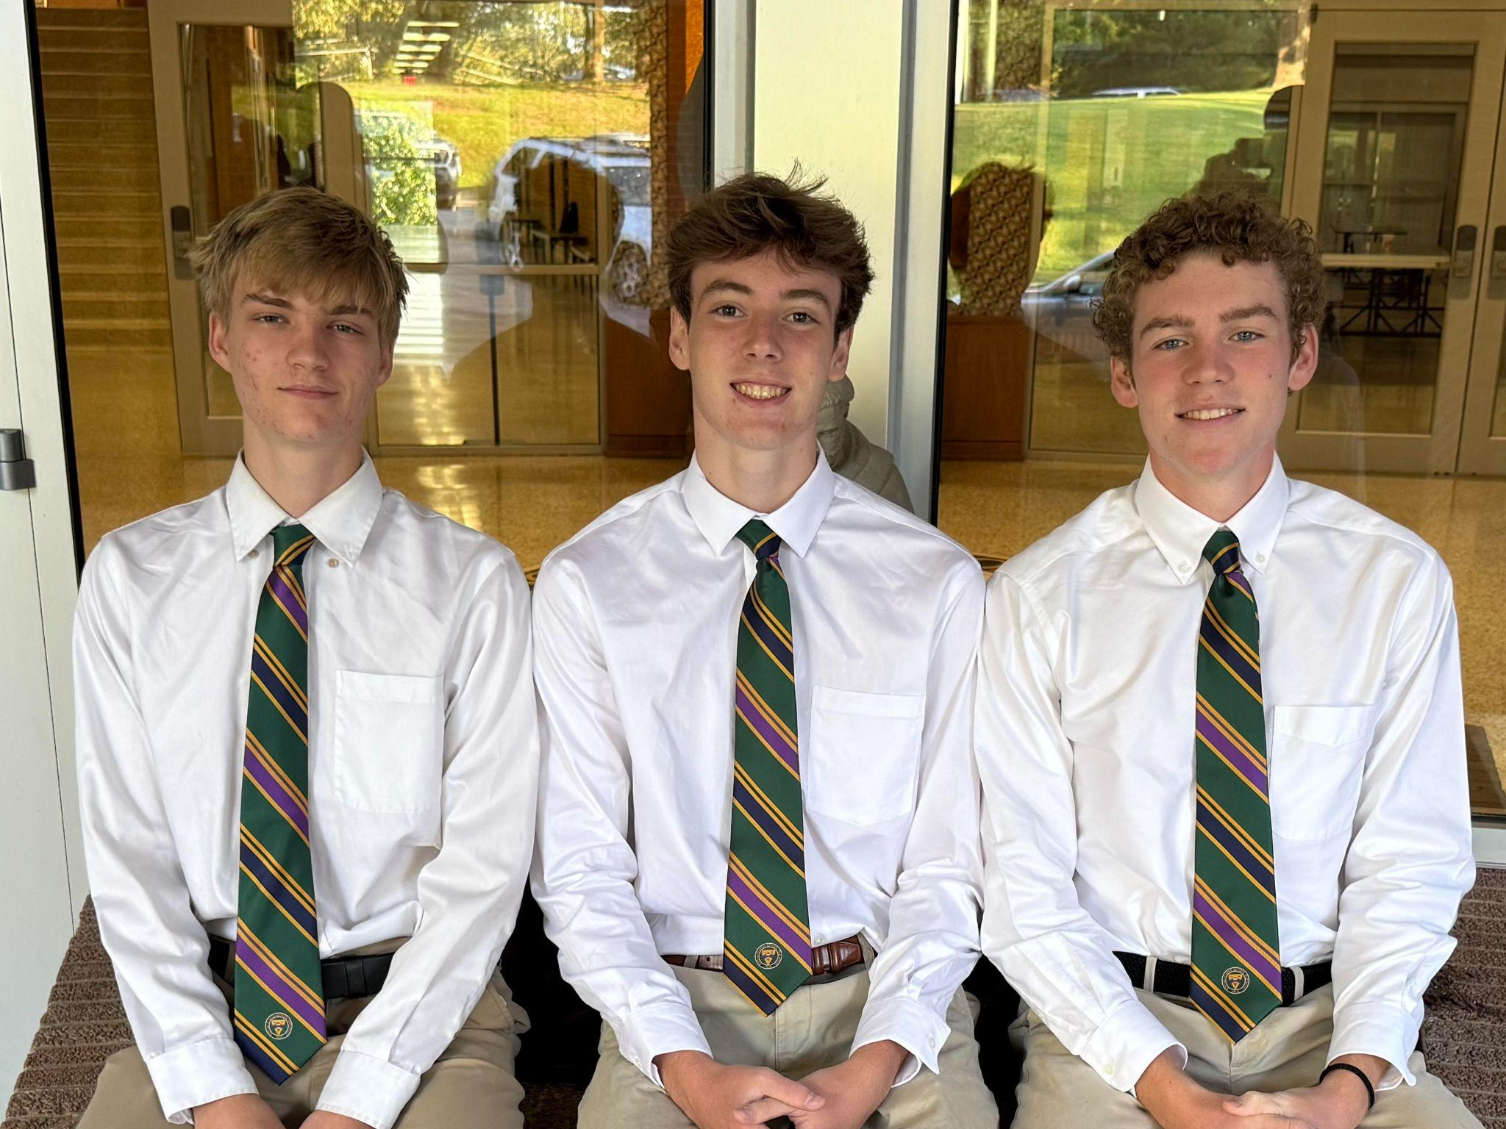

LITTLE ROCK, Ark. (Sept. 12, 2025) — Catholic High School for Boys is proud to announce that seniors Gage Bennett, Whit Butler and Noah Simon have been named National Merit Scholarship Program Semifinalists.
“This recognition is one of the highest academic honors available to high school students,” said Steve Straessle, Catholic High Head of School. “It is not only a testament to the intelligence and dedication of Gage, Whit and Noah, but also to the environment of excellence fostered here at Catholic High.”

The honor places them among the top 16,000 high school seniors nationwide recognized in the 71st annual competition, representing less than one percent of U.S. high school seniors. More than 1.3 million juniors from 20,000 high schools entered the program by taking the 2024 Preliminary SAT/National Merit Scholarship Qualifying Test (PSAT/NMSQT®).
Semifinalists now have the opportunity to advance in the competition for nearly 7,000 National Merit Scholarships worth about $26 million, to be awarded next spring. To become a Finalist, each student and a high school official must submit a detailed scholarship application that highlights academic performance, activities, leadership and an essay, along with SAT® or ACT® scores that confirm their earlier qualifying performance.
About Catholic High School for Boys
Catholic High School for Boys, a college-preparatory high school in Little Rock, was founded by Bishop John B. Morris of the Diocese of Little Rock in 1930 to ensure that boys in the Little Rock area had access to quality Catholic secondary education. Nearly a century later, CHS continues its tradition of aiding boys of all faiths in their spiritual and academic growth. The school continues to provide boys the foundation needed to become outstanding fathers, husbands and leaders in their communities. Learn more at: www.lrchs.org.
###

